
Branding Audit Report
Current versus optimized LinkedIn profile and positioning
SAMPLE DATA. This report was generated from a fictional person and illustrative figures so you can see the finished format. It is not a real result.

Document control
Project | LinkedIn Influence Lab (Phase 1, 6 weeks)
Project code | LIL-2025-P1
Document | Branding Audit Report
Prepared for | Riya Mehta (Sample), Senior Operations Analyst
Learning path | Working Professional
Version / date | 1.1 · 13 November 2026
Classification | Confidential: client use

1. Summary
44/100  Profile health score | Needs work  Assessment | 7  Checklist gaps | 5  Content pillars

The profile scores 44 out of 100 against a 12-point checklist drawn from the project brief. 7 items need attention; the five highest-value fixes are listed in section 3.

2. Profile checklist
Checklist item | Points | Score | Status | Recommended fix
Professional profile photo | 8 | 8 | OK
Banner that states your value | 6 | 0 | Gap | Replace the default banner with one line on who you help and how.
Keyword-rich headline (60-220 chars) | 14 | 9 | Gap | Use: role | who you help / what you do | 2-3 skills. Avoid a bare job title.
About section with proof and a call to action | 14 | 3 | Gap | Write 600-1,500 characters: hook, proof, what you post about, how to reach you.
Custom profile URL | 4 | 4 | OK
Featured section populated | 8 | 0 | Gap | Pin your best post, a project, and a link that proves your skills.
15+ skills, top 3 pinned | 6 | 6 | OK
3+ recommendations | 8 | 8 | OK
Experience bullets include numbers | 12 | 0 | Gap | Rewrite each role with one measurable result.
Contact info and a clear call to action | 6 | 0 | Gap | Add email or a booking link in contact info.
Posting at least 8 times a month | 8 | 0 | Gap | Start with the 6-week calendar from this project.
500+ connections | 6 | 6 | OK

3. Priority actions
- Experience bullets include numbers: Rewrite each role with one measurable result. (up to +12 points)
- About section with proof and a call to action: Write 600-1,500 characters: hook, proof, what you post about, how to reach you. (up to +11 points)
- Featured section populated: Pin your best post, a project, and a link that proves your skills. (up to +8 points)
- Posting at least 8 times a month: Start with the 6-week calendar from this project. (up to +8 points)
- Banner that states your value: Replace the default banner with one line on who you help and how. (up to +6 points)

4. Headline: current and optimized
 | Headline
Current | Senior Operations Analyst at Northwind Logistics
Option 1 | Senior Operations Analyst at Northwind Logistics | Helping operations and supply chain professionals with Excel | SQL · Power BI
Option 2 | Senior Operations Analyst | Excel · SQL · Power BI | Sharing lessons from supply chain analytics
Option 3 | Senior Operations Analyst at Northwind Logistics | I turn Excel into clear decisions for operations and supply chain professionals

5. About section: optimized draft
Before you use it Source: Template engine. Replace every [bracketed placeholder] with a real, verifiable example before publishing.

I am a Senior Operations Analyst in supply chain analytics who helps operations and supply chain professionals make better use of Excel.
What I bring:
• Rebuilt our weekly delivery-performance report as a Power BI dashboard, cutting preparation time from 5 hours to 40 minutes.
• I once presented a cost-saving figure without checking for duplicate shipment IDs; the number was 8% too high until a colleague caught it.
• A 10-minute data check before any review meeting saves hours of damage control.
What I write about: career insights, thought leadership, personal journey, industry trends, actionable tips.
Skills I use most: Excel, SQL, Power BI, Process Improvement, Stakeholder Communication.
Always happy to swap notes. Connect or send me a message.

6. Content pillars
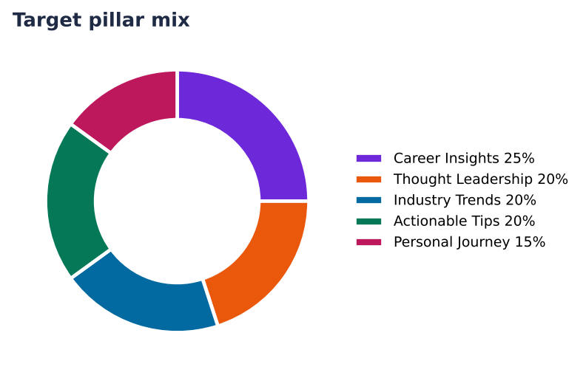
Figure 1. Target pillar mix for the six-week plan
Pillar | Share | Posts in 6 weeks | What it covers | Example topic
Career Insights | 25% | 4 | Hard-won lessons about growth, promotions and decisions. | The best career advice I ignored for years (and what finally changed my mind)
Thought Leadership | 20% | 4 | Opinions, frameworks and bets that make people think. | Unpopular opinion: most supply chain analytics advice about Excel is outdated
Industry Trends | 20% | 4 | What is changing in your field, explained in plain English. | 3 shifts in supply chain analytics that operations and supply chain professionals should watch this quarter
Actionable Tips | 20% | 4 | Checklists, templates and habits people can use today. | 5 minutes a day on Excel: the routine that actually stuck
Personal Journey | 15% | 3 | Honest stories: wins, mistakes and what you are learning. | My biggest mistake as a Senior Operations Analyst (and the lesson I still use)

7. Role-model benchmark
Role model | Profile | What to learn
Sample Peer A | https://www.linkedin.com/in/sample-peer-a | One clear takeaway in every weekly carousel
Sample Peer B | https://www.linkedin.com/in/sample-peer-b | Short stories about process fixes
Sample Peer C | https://www.linkedin.com/in/sample-peer-c | Honest posts about mistakes and what changed

8. The three user paths compared
Path | Goal | Rhythm | Pillar mix | KPIs
Working Professional | Visibility and credibility inside my niche. | Tue, Wed, Thu | Career Insights 29%, Thought Leadership 24%, Industry Trends 24%, Actionable Tips 24% | Impressions, Comments, Profile visits
Job Seeker | Recruiter attention, interviews and inbound opportunities. | Mon, Wed, Fri | Actionable Tips 33%, Personal Journey 28%, Career Insights 22%, Industry Trends 17% | Profile visits, Recruiter messages, Connection requests
Thought Leader / Entrepreneur | Authority, followers, shares and inbound leads. | Tue, Thu, Sat | Thought Leadership 33%, Industry Trends 28%, Actionable Tips 22%, Personal Journey 17% | Followers gained, Shares, Inbound leads

